

Self Start On-line Clinic at Marcotte Physiotherapy

Assignment Workbook

Fall 2017

Revision History

|  |  |  |  |
| --- | --- | --- | --- |
| **Date** | **Issue** | **Description** | **Author** |
| 06/12/2017 | Fall 2017 | Final E-R Diagram Created | Leo Zhang, Sooruj Ghangass, Tomiwa Ademidun, Andrew Hart, Nicholas Vukelic, Brian He |
| 06/12/2017 | Fall 2017 | Final Report Created – All Sections | Leo Zhang, Sooruj Ghangass, Tomiwa Ademidun, Andrew Hart, Nicholas Vukelic, Brian He |

Table of Contents

Potential Entity Classes 4

Classes Attributes 5

Entity Class Diagram 8

# Potential Entity Classes

|  |  |
| --- | --- |
| Class name | Brief Description |
| User | Entity class that stores general personal information like name, email, phone number. |
| Admin | Entity class that stores personal information that is specific to the system administrator. |
| Physiotherapist | Entity class that stores personal information specific to each physiotherapist. Includes information like license number. |
| Patient | Entity class that stores personal information specific to an individual patient. Includes information like DOB, gender, height, weight. |
| Payment | Entity class that stores transaction specific to an individual payment. Includes information like account numbers, transaction date and payment amount and type. |
| Appointment | Entity class that stores information specific to an individual appointment. Includes information like appointment date, type, description and notes. |
| Treatment Plan | Entity class that stores information specific to an individual treatment plan. Includes information like the treatment duration, description, type of injury, and treatment plan status. |
| Exercise | Entity class that stores information specific to an individual exercise. Includes information like exercise id, name, description and a link to a multimedia resource. |
| Form | Entity class that stores general form information like date created, date completed, description and questions. |
| Question | Entity class that stores information specific to an individual question. Includes information like the question and response. |
| Self-Assessment | Entity class that stores information specific to an individual self-assessment. Includes the patient’s self-reflection. |
| Injury Report | Entity class that stores information specific to an individual injury report. Includes information like injury type and severity. |

# Classes Attributes

1. ***User* class**

|  |  |  |
| --- | --- | --- |
| Attribute name | Type | Brief Description |
| id | int | Unique id of the user |
| firstName | string | First name of the user |
| lastName | string | Last name of the user |
| email | string | User's email |
| username | string | User's username |
| password | string | Login password |
| phoneNo | int | Phone number of the user |

1. ***Physiotherapist* class**

|  |  |  |
| --- | --- | --- |
| Attribute name | Type | Brief Description |
| licenseNo | string | License number required to practice physiotherapy |

1. ***Patient* class**

|  |  |  |
| --- | --- | --- |
| Attribute name | Type | Brief Description |
| DOB | date | Date of Birth of the patient |
| address | string | Patient's address (Street Number, Street Name, City, Postal Code, and Region) |
| healthCardNo | int | Patient's Health Card Number |
| maritalStatus | string | Patient's marital status |
| occupation | strin | Patient's occupation |
| id | int | Unique id of the patient |

1. ***Payment* class**

|  |  |  |
| --- | --- | --- |
| Attribute name | Type | Brief Description |
| date | date | Date of payment |
| amount | double | The dollar amount of the transaction |
| accountFrom | string | The withdrawn account |
| accountTo | string | The receiving account |
| paymentType | string | Type of payment (i.e. Visa, Mastercard, Bitcoin.) |
| confirmationCode | string | Code to confirm the payment was completed |
| id | int | Unique id of the payment transaction |

1. ***Appointment* class**

|  |  |  |
| --- | --- | --- |
| Attribute name | Type | Brief Description |
| dateTime | date | Date and time of the appointment |
| description | string | Description and purpose of the appointment |
| duration | int | Length of the appointment (in minutes) |
| physioNotes | string | Notes made by the physiotherapist |
| id | int | Unique id of the appointment |

1. ***Treatment Plan* class**

|  |  |  |
| --- | --- | --- |
| Attribute name | Type | Brief Description |
| startDate | date | Start date of the plan |
| endDate | date | End date of the plan |
| description | string | Description of the treatment |
| overallRehabGoal | string | Description of the overall rehabilitation goal this plan is trying to achieve |
| name | string | Name of the treatment plan |
| authorName | string | Author of the treatment plan |
| id | int | Unique id of the treatment plan |

1. ***Exercise* class**

|  |  |  |
| --- | --- | --- |
| Attribute name | Type | Brief Description |
| id | int | Unique id of the exercise |
| name | string | The name of the exercise |
| description | string | The description of the exercise |
| multimediaLink | string | A link to multimedia content demonstrating the exercise |
| authorName | string | Author of the exercise |
| objectives | string | Objectives the exercise is supposed to achieve |
| actionSteps | string | A step by step description of how to perform the exercise |
| location | string | Location on the body the exercise will affect |
| frequency | int | Frequency, in number of repetitions, the exercise should be performed |
| Duration | int | Duration the exercise should be performed for, in seconds |
| targetDate | date | Date the exercises should be completed until |

1. ***Form* class**

|  |  |  |
| --- | --- | --- |
| Attribute name | Type | Brief Description |
| id | int | Unique id of the form |
| dateCreated | date | Date of creation for the form |
| dateCompleted | date | Date the patient or other user fills out the entire form |
| description | string | Description of the form |
| name | string | Name of the form |

1. ***Question* class**

|  |  |  |
| --- | --- | --- |
| Attribute name | Type | Brief Description |
| id | int | Unique id of the question |
| question | string | Question on the form to be asked |
| response | string | User’s response to the question |

1. ***Self Assessment* class**

|  |  |  |
| --- | --- | --- |
| Attribute name | Type | Brief Description |
| assessmentRubric | string | The rubric by which the physiotherapist will evaluate the patient’s self assessment |

1. ***Injury Report* class**

|  |  |  |
| --- | --- | --- |
| Attribute name | Type | Brief Description |
| injuryType | string | Type of injury (i.e. fracture, concussion, etc.) |
| severity | string | Severity of the injury (i.e. minor, life-threatening, etc.) |

# Entity Class Diagram

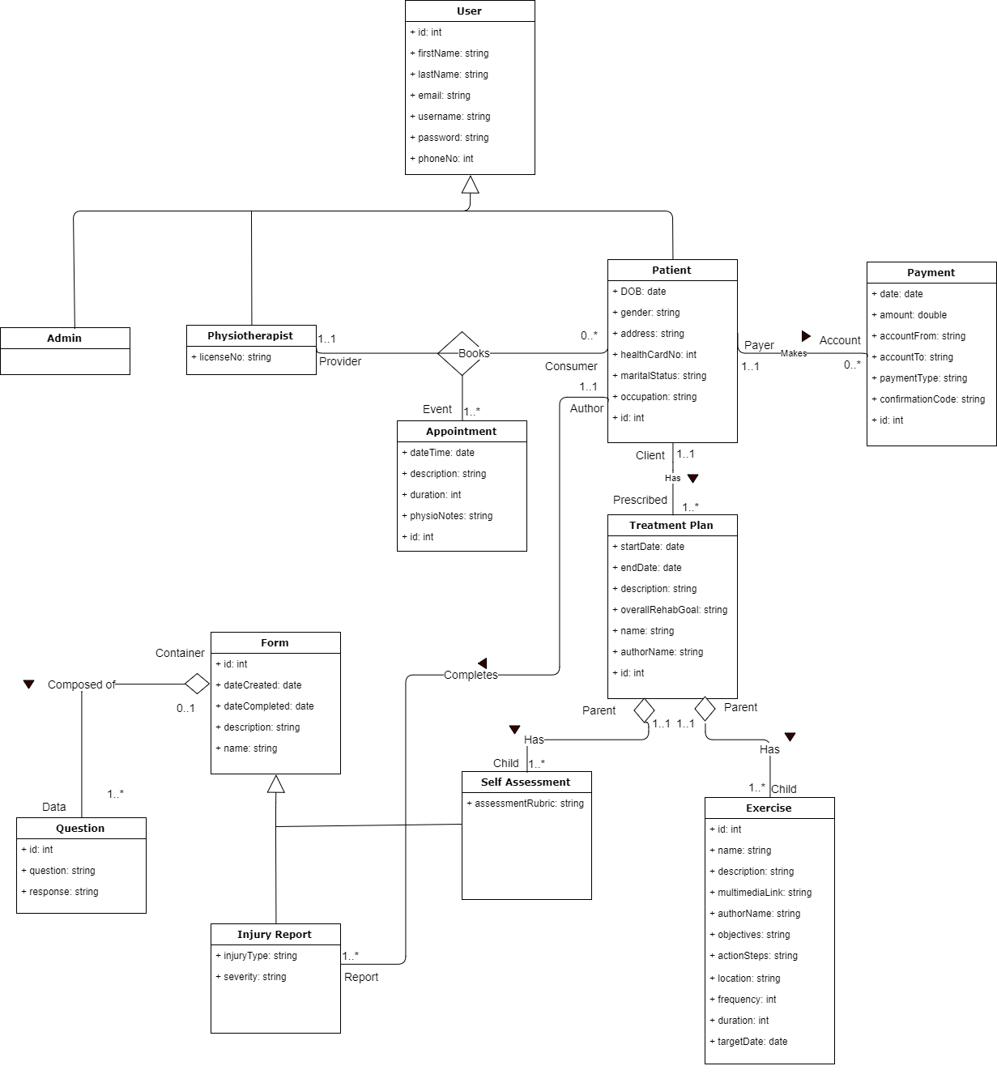

Notes:

* Where inheritance is present, the “id” is a part of the parent class (e.g. User and Form) as opposed to the child classes.
* Forms (e.g. Self-Assessment and Injury Report) consist of one to many questions, which are represented by Question entities that hold the question and the patient’s response.
* We used Aggregation for the has-a relationships. Forms have Questions, and Treatment Plans have Self Assessments and Exercises. Aggregation was used over composition, since child objects belong to a parent object, but will not be destroyed if the parent is deleted. For example, a Treatment Plan could be destroyed and the Self Assessments and Exercise can continue to persist.